Community-Based Learning End of Semester Report – Fall 2019
Each semester the Center for Public Impact compiles a report highlighting the community-based learning (aka service-learning) course sections, enrolled students, and student satisfaction data.

Scope of Community-Based Learning Courses
Data Source: CSS and *FalconInfo
# of Courses Offered |  | # of Sections Offered |  | # of Undergraduate Students* |  | # of Graduate Students |  | Total # of Students
36 |  | 55 |  | 1039 |  | 37 |  | 1076
Distribution by Academic College
College | Sections |  | % of sections |  | Number of students enrolled in CBL*  Graduate & Undergraduate |  | Percent distribution of CBL students by college*  Graduate & Undergraduate
A&S | 28 |  | 51 |  | 355 |  | 32
EDHD | 7 |  | 13 |  | 174 |  | 15
CBA | 1 |  | 2 |  | 32 |  | 3
CHHS | 14 |  | 25 |  | 373 |  | 33
CTAAE | 3 |  | 5 |  | 92 |  | 8
CMA | 0 |  | 0 |  | 2 |  | .1
Firelands | 2 |  | 4 |  | 30 |  | 3
*Falcon Info Data as of Dec. 2019

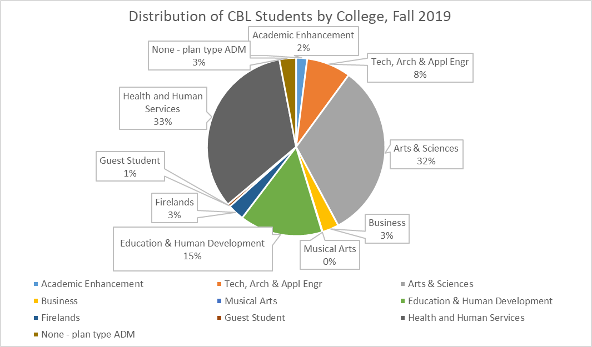

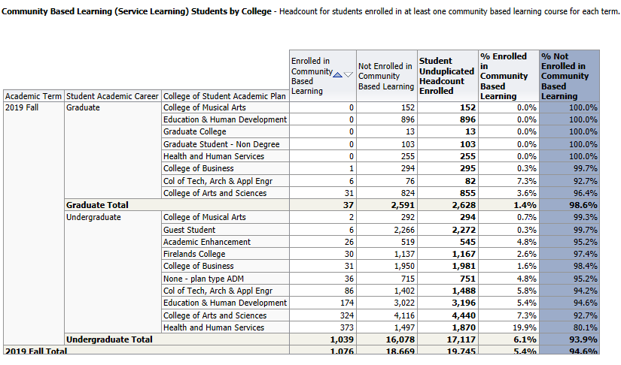

The information below highlights the courses offered (graduate and undergraduate) with the CBL course attribute value in CSS.

Community-Based Learning Courses Fall 2019

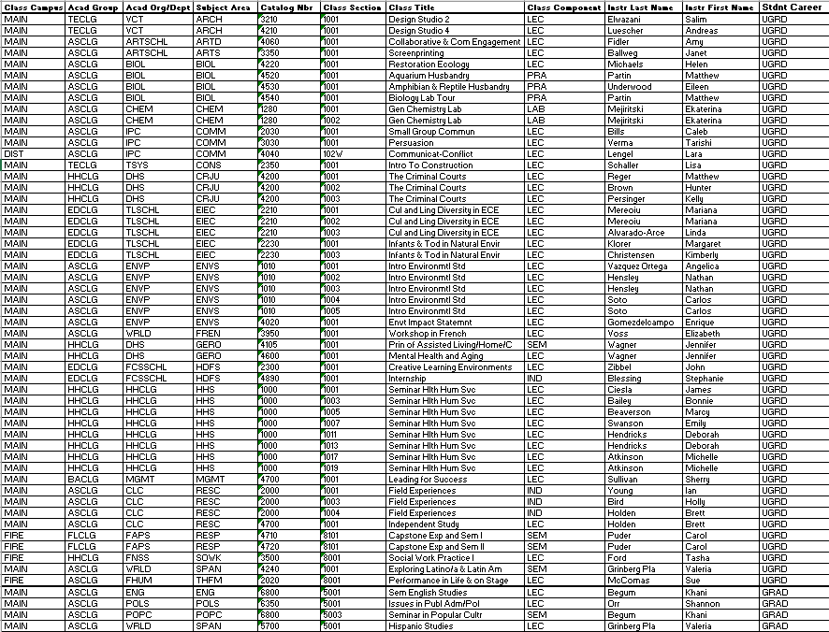

Impact on Student Learning
Information in this section was compiled from data gathered primarily from the End of Semester CBL Student Survey. At the end of the fall and spring semesters, all service-learning students were asked to complete an optional end of semester evaluation regarding their experience with service-learning. Students were asked to rate 12 specific attributes using a 5-point scale ranging from strongly disagree to strongly agree.

Fall 2019 Response Rate: 167 students completed the Fall 2019 survey out of a total of 1076 students enrolled for a 16% response rate.

Survey Questions:
1. Service-learning made the class more interesting.
2. Service-learning helped me further understand the core concepts and theories of the course.
3. Performing the service-learning project helped me clarify which major and/or profession I might pursue.
4. Service-learning enhanced my ability to develop communication skills in this class through class presentations, discussions, journal entries, or other formats.
5. Through service-learning, I gained practical experience that I believe will make me more marketable to employers, graduate schools, or scholarship reviewers.
6. This class helped me become interested in contributing to the larger community.
7. This course helped me understand the importance of taking the perspectives of others seriously.
8. The service-learning component caused me to think about my own attitudes, values, and perspectives.
9. I was aware that this course had a service-learning component when I registered for the class.
10. Directions on how to get started with the service-learning experience were clear.
11. I was made aware of how my service would impact a community need.
12. I would recommend this service-learning course to other students.

